TECHNICAL PROJECT REPORT

# Title of Invention / Project: voice alphabetical printer

# Team Members / Inventors:

|  |  |  |  |  |  |
| --- | --- | --- | --- | --- | --- |
| **S.No.** | **Name** | **Department** | **Designation** | **Mobile** | **E-Mail** |
| 1. | Archit madaan | CSE-IS2 | student | 9988775910 | architmadaan66ldh@gmail.com |
| 2. | Ankur vig | CSE-IS2 | student | 9878541985 | Ankurvig123@gmail.com |
| 3. | Rohit arora | CSE-IS2 | student | 7206633307 | noorohit55@gmail.com |
| 4 | Khushal Thakur | ECE | Mentor | 9646030764 | khushal.thakur@cumail.in | 9646030764 | khushal.thakur@cumail.in |
| 5. | Anshul Sharma | ECE | Mentor | 9478697475 | anshulsharma.ece@cumail.in |
| 6. | Kiran Jot Singh | ECE | Mentor | 9463909689 | kiranjotsingh.ece@cumal.in |
| 7. | Divneet Singh Kapoor | ECE | Mentor | 9878422653 | divneet.ece@cumail.in |
|  |  |  |  |  |  |

Section – 1 (IPR Related)

* Problem your project is solving :

As our project name is voice alphabetical printer in which we use voice recognition app to send message to the Bluetooth and Bluetooth sends the message to LCD due to which our message is shown on LCD screen. By using this we can without using manpower be able to print our message on LCD. That helps us to make our work easy and fast. As we all know that in today’s era the work load is very high on every professional individual so it will help the individuals to reduce their word burden and to do work with great ease. In companies we can use voice printer so that people can gain access to information.

One of the main objective of this project is to solve the problems faced by blind people. They are not able to understand the language we use in reading and writing because they use the special language that is the Brail language.

* How are you solving that (solution)?

In our project we are using LCD as an output source by giving a vocal input. In our project we are using Bluetooth, Arduino, LCD as main components. In this project we are connecting Bluetooth and LCD with arduino and by giving proper code we are making this project work. This project works in a way that vocal message as input is given and than this voice message is sent to the Bluetooth and than Bluetooth send it to LCD and message get printed.By modifying this project we can make it a better tool that can help the society by adding new things in this project. We can modify the project by replacing LCD with a CNC plotter or printer that can help the blind people in writing and we can also modify it in another way by using the new tool that can make a brail that can help the blind people in reading also. After amending it can solve many problems faced by blind people in reading or writing.

* Additional modifications that can cater to improve the solution

In order to make this project more efficient we can make additional modification by adding CNC plotter. By adding this modified tool we can enhance the property and application of this project and by this modification we can take our project to that level which can help the society and make the technological work more easy and efficient.

# Existing state-of-the-art and Drawbacks in existing state-of-the-art

|  |  |  |
| --- | --- | --- |
| **S. No.** | **Existing state of art** | **Drawbacks in existing state of art** |
| 1 | Message shown on LCD  https://www.youtube.com/watch?v=ZBol-qpKjGQ | It can only be printed on LCD not on any other device. |
| 2 | Sending vocal messages  https://www.youtube.com/watch?v=ZBol-qpKjGQ | Not very reliable because technical error can occur. |

FEATURES:

* Use of efficient manpower to handle technical error that can occur in vocal inputs.
* Addition of new technology which can make it workable on other devices also.

ADVANTAGES:

* We can get proper vocal output.
* It will become more reliable and efficient.

# Block Diagram

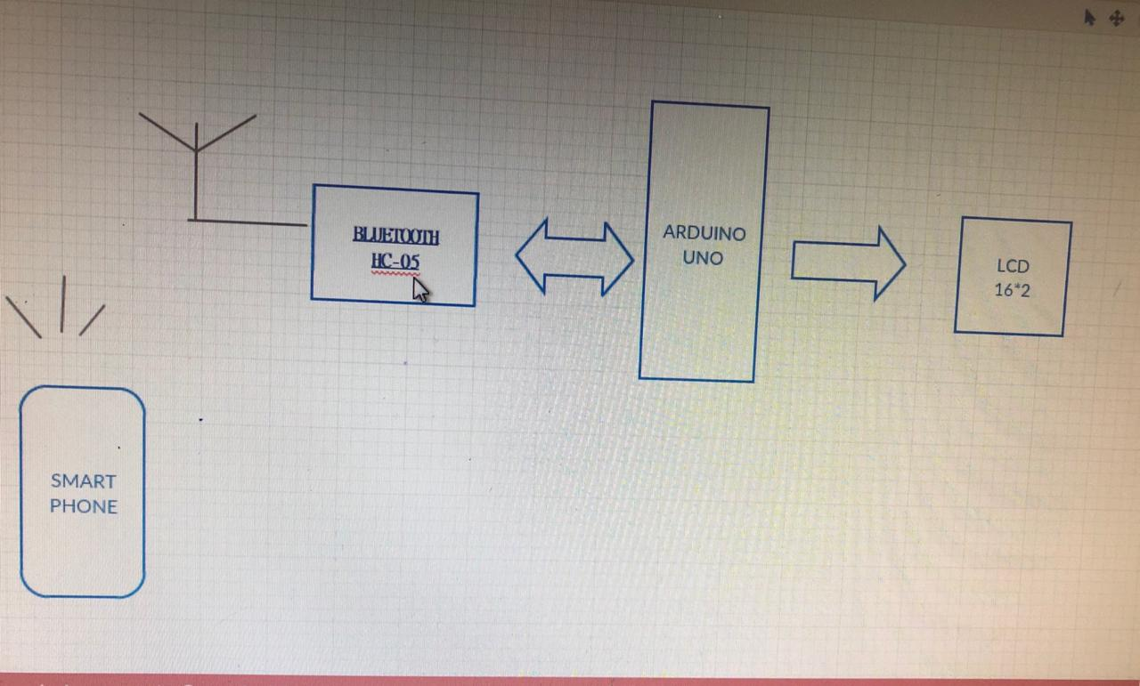

Section – 2 (Real Project)

# Materials

1. Arduino UNO ( 1 unit)
2. Bluetooth ( HC-05)( 1 unit)
3. Jumper wires (7 unit)
4. Connecting wires(8 unit)
5. LCD( 1unit)
6. Breadboard(1 unit)
7. Potentiometer(i unit)

# Circuit Diagram

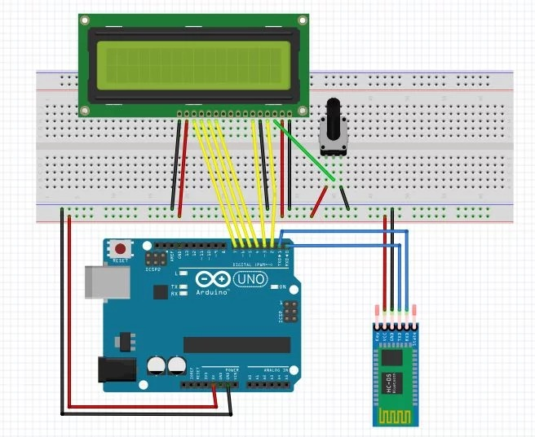

# Steps of Circuit Completion

Step 1; Firstly, we collect the all components of the project.

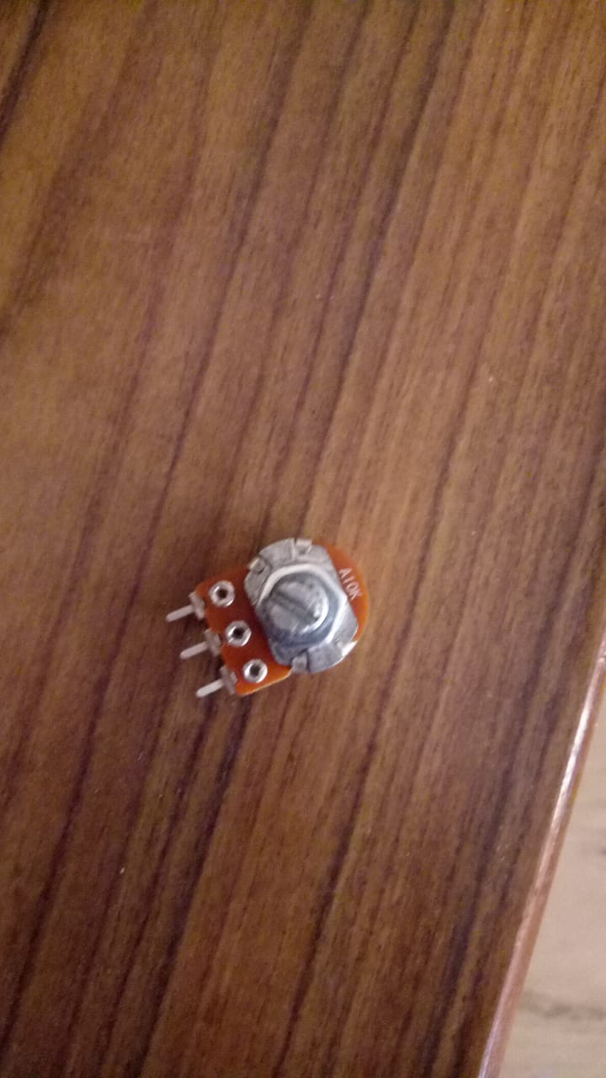 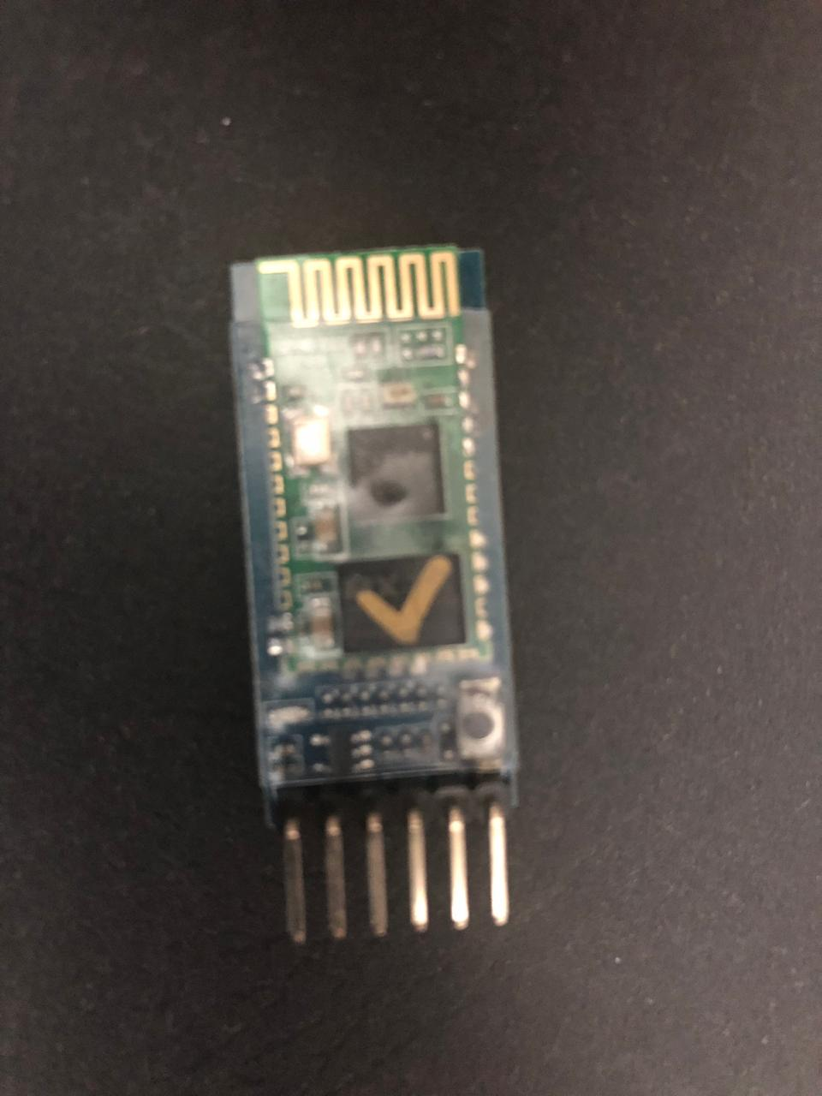

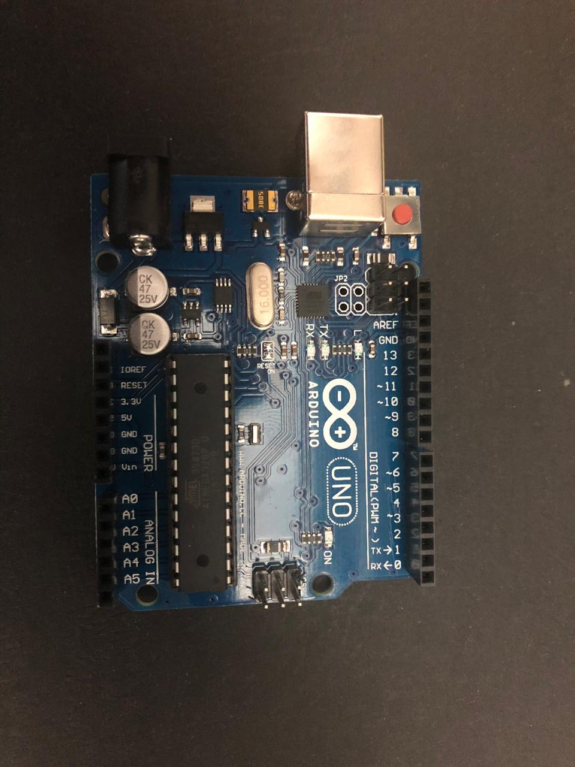

Step 2:Then we connect Bluetooth with arduino Then we connect LCD with potentiometer.

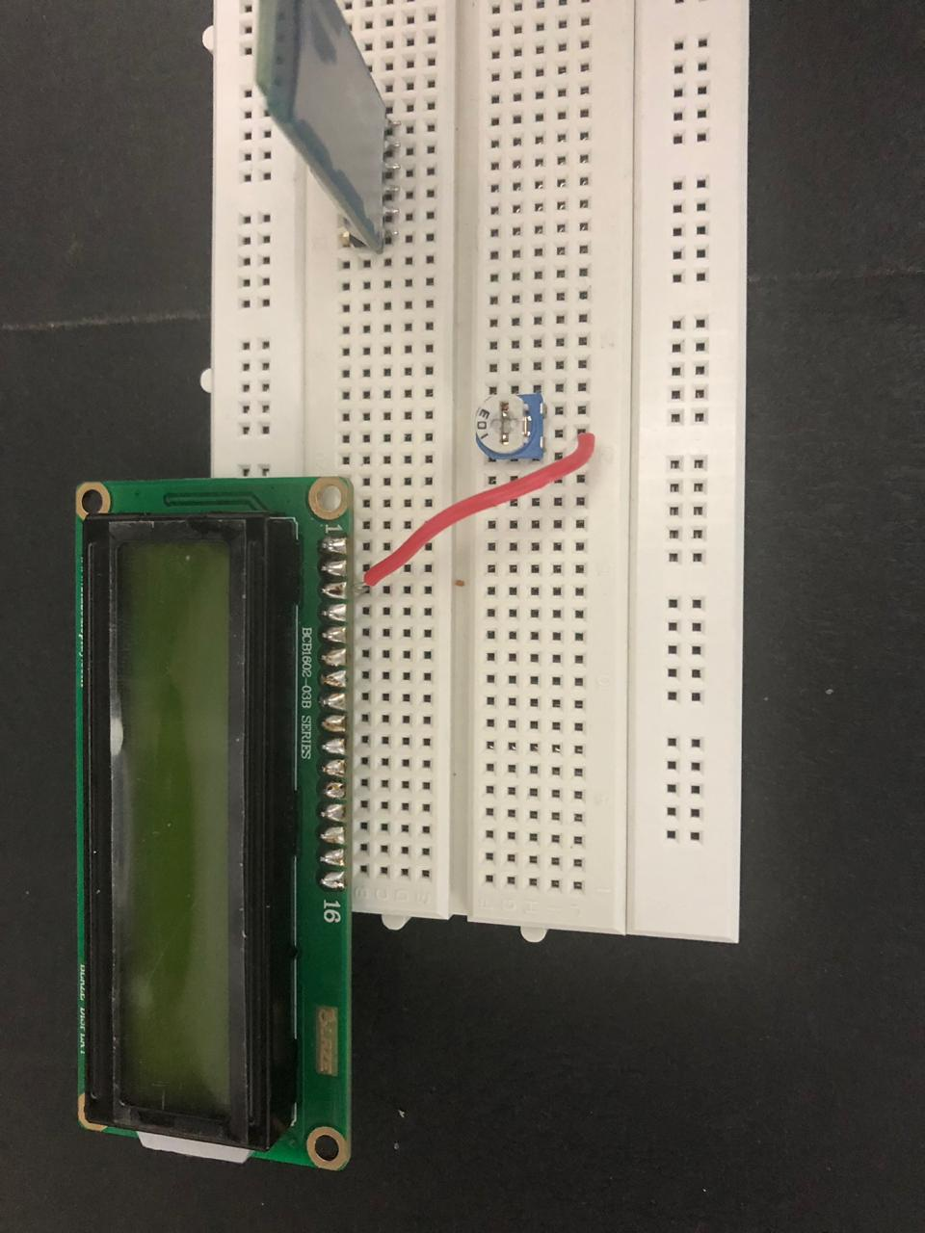

step 3: in next step we connect LCD and Bluetooth with arduino and make connections according to the circuit. 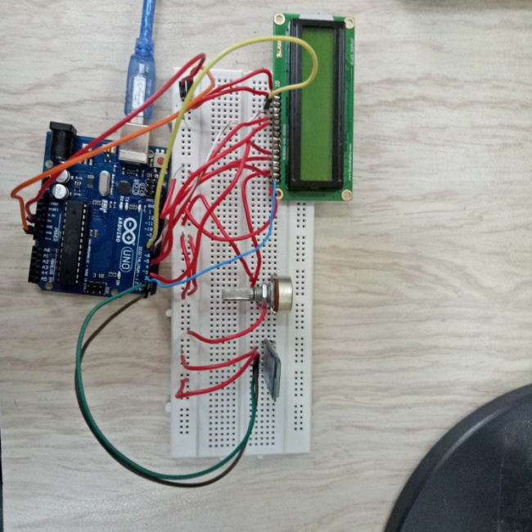 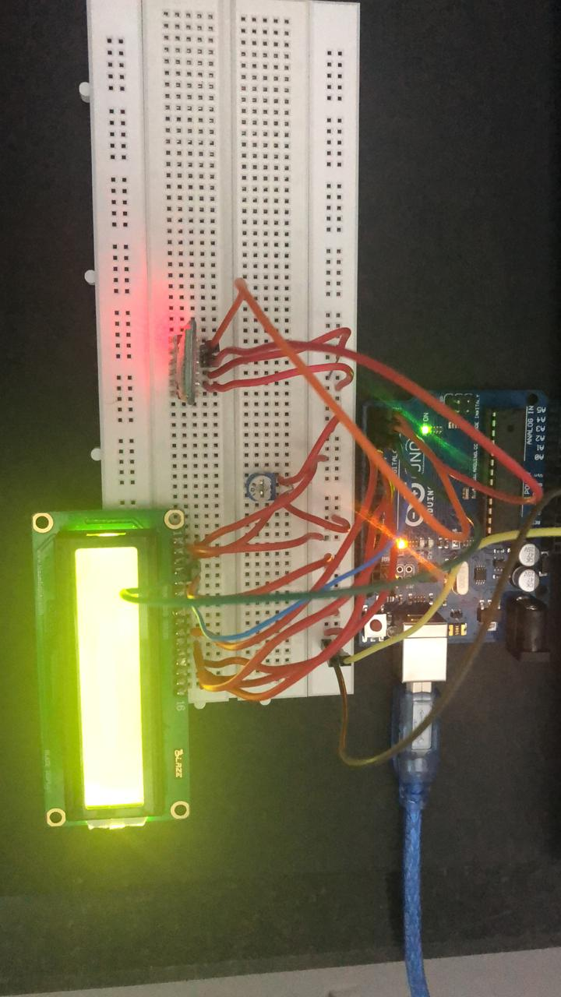

# step 4:then after circuit get completed and project start working.

# Program Code

https://github.com/Voice-Alphabetic-Printers

